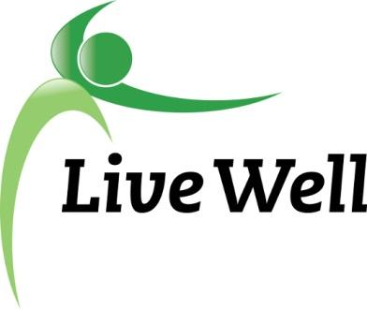
AGENDA

Healthy Food for All Work Group
Virtual Meeting via Google Hangouts: meet.google.com/kft-zamj-kwv

2:00pm – 3:30pm, Thursday, January 14th, 2021

Agenda items | Notes | Action Items
Introductions | - Welcome everyone! Introductions, Accomplishments, and Ice Breaker: What is something you are NOT going to change in 2021?  - Review 2021 Vision Survey
Announcements | - Local Food Access Mapping Project (survey) - https://www.surveymonkey.com/r/FoodMap  - CDRR (Chronic Disease Risk Reduction) Grant- Identify Priority  - Support healthy food systems and improved access to foods in community settings by forming a food policy council, or advancing one or more food policy council priorities through policy, systems, and environmental changes.  - Support healthy food systems and improved access to foods in community settings by establishing new farmers markets, expanding farmers markets, or promoting use of Senior Farmers Market Nutrition Program (SFMNP), Supplemental Nutrition Assistance Program-Electronic Benefits Transfer (SNAP-EBT), and Double-Up Food Bucks (DUFB) at farmers markets.  - BCBSKS Pathways Grant  - Cruising Cupboard Outreach within Agencies  - KU Program Planning Class - Kelsey | - Food mapping project underway and most data has been sent to MPO. Laura will keep us updated with it’s progress  - HFFA will help in Kelsey’s Program Planning class where students help to write a grant based on a topic we choose  - Food pantry delivery system was recommended as a possible topic area  - CDRR grant - helping to support Double Up Food Bucks as well as the Senior Farmers Market program came up as a potential focus area  - Marty updated us on BCBSKS grant, workgroup members can help support by reviewing packages  - Ryan will be sharing a survey about gathering data from agencies in relation to the Cruising Cupboard  - United Healthcare update - Celia informed the group of the potential for members to receive transportation services
Sharing of Resources/ Community Needs | - #DGKS campaign is being used on social media to share resources. Amy Albright from Lawrence Arts Center has yard signs, bumper stickers, and window decals to market this campaign. You can contact her to get some for you or your organization: amy@lawrenceartscenter.org Print and Web materials
HFFA Leadership Transition | - New chairs? July transition.
On-Going Projects | Community Health Plan- Food Access in Schools Measure (pending)
Adjourned | - Next Meeting - Feb. 25, 2021 2-3:30pm

